DAY 1  NORWAY_ SKIPTVET

Slika na kojoj se prikazuje osoba, na otvorenom, ljudi, stajanje

Opis je automatski generiran​​​​​​​On the first day our Norwegian hosts welcomed us in their school hall together with their municipality representative.

After introducing each team pupils went on handball practice were they learned basics of hardball; steps, catching the ball, passing the ball, jumping and similar.. During that time teachers had chance to get know the school environment.

After school pratice we all together went in municipality building to see the

Slika na kojoj se prikazuje pod, sport, atletska disciplina, grupa

Opis je automatski generiranSlika na kojoj se prikazuje strop, zgrada, ljudi, grupa

Opis je automatski generiran​​​​​​​

exhibition of Norway famous paraolympic Jan Erik Stenberg ...

Later our host showed us their beautiful school where they have exposed wall of fame; famous sportist of theor country. After a short lecture about each one from the wall we all got a little notebook with the pitcures and all informations about each one of them.

During the evening pupils continue to bond and have fun on local pool.

DAY 2 NORWAY-SKIPTVET

During the morning we all gather in school gym.

Pupils were divided in 2 groups. One group had handball pratice and other was outside with the teachers palying frisbee.

Slika na kojoj se prikazuje tekst, sport, atletska disciplina

Opis je automatski generiranOur host have very nice outside field for that sport and all teams beside Slovakian played it on this way for the first time.

Slika na kojoj se prikazuje strop, pod, tlo, na zatvorenom

Opis je automatski generiran Slika na kojoj se prikazuje na zatvorenom, pod, sport, strop

Opis je automatski generiran

It was very fun and challenging to put the frisbee in the far metal basket in as little as possible  throws.

Slika na kojoj se prikazuje tekst, strop, na zatvorenom, ljudi

Opis je automatski generiranAfter sport activities we went in the school where we watched presentations of each team in which they had presented their school and town.

During the evening kids visited local youth club where they played games, listened the music and danced..

DAY 3 NORWAY - SKIPTVET

We started the day going to Vamma.

After nice walk through the woods and enjoying in very beautiful nature we visited waterpowerplant. With expert guidance we walked all around it and also have entered inside to look thr engines and to hear about history and way how it produces the energy.

Slika na kojoj se prikazuje osoba, na zatvorenom, poziranje, ljudi

Opis je automatski generiran

Before meeting with the Norwegian famous trials driver Ingveig Håkonsen pupils watched handball pratice and after that we all walked to school where Ingveig joined us.

Slika na kojoj se prikazuje nebo, na otvorenom, osoba, stajanje

Opis je automatski generiran Slika na kojoj se prikazuje nebo, stablo, na otvorenom, čamac

Opis je automatski generiran

Kids were thrilled with her story. She was really an inspiration for the. Sharing her story about handling the school and pratice, being close to their age you could really feel how kids connected with her. It was wonderful to hear their impressions afterwards.

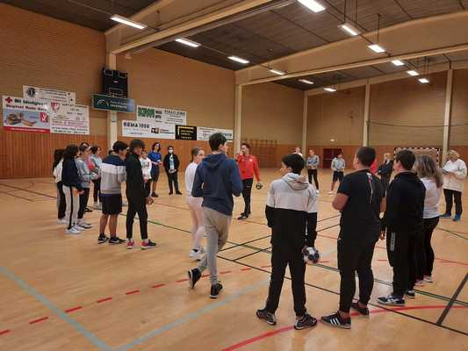​​​​​​​

During the evening we all enjoyed in handball natch were we gave support to lical Skiptvet team. In the team played students that were involved un the project so our guest pupils had a strongly will to cheer them with all of their heart. "Our" team won so it was celebration.

DAY 4 NORWAY - SKIPTVET

In the morning we visited spectacular Holmenkollen.

Slika na kojoj se prikazuje tekst

Opis je automatski generiran

We enjoyed in their museum and after all kids had a chance to climb on the jumping level.

Slika na kojoj se prikazuje sisavac, na zatvorenom, stajanje

Opis je automatski generiran

Luckily for us local ski jumpers had their pratice so we had a chance to see and to feel live how it looks like.

Afternoon was reserved for visiting the Oslo. Capital city.

Slika na kojoj se prikazuje tekst, zgrada, na otvorenom, ulica

Opis je automatski generiran

First we visited Vigelandsparken and after we went in the center were we saw Oper House, new Public library and Memorial centre 22. July.

After returning to Stenbekk house we had closing ceremony.

DAY 4 NORWAY - SKIPTVET

In the morning we visited spectacular Holmenkollen.

Slika na kojoj se prikazuje tekst

Opis je automatski generiran

We enjoyed in their museum and after all kids had a chance to climb on the jumping level.

Slika na kojoj se prikazuje sisavac, na zatvorenom, stajanje

Opis je automatski generiran

Luckily for us local ski jumpers had their pratice so we had a chance to see and to feel live how it looks like.

Afternoon was reserved for visiting the Oslo. Capital city.

Slika na kojoj se prikazuje tekst, zgrada, na otvorenom, ulica

Opis je automatski generiran

First we visited Vigelandsparken and after we went in the center were we saw Oper House, new Public library and Memorial centre 22. July.

After returning to Stenbekk house we had closing ceremony.

DAY 5 NORWAY - SKIPTVET

Day was reserved for the trip back home. Because of the pandemic situation and still needing to take covid test for going home all teams prefered to start their trip home on Friday.

On the end it was wise decision because returning wasn't easy. Some teams spent hours on the airport, returning home vlose to midnight and some even on Saturday.