- DAY 1

This monday was the first day of our project Citius, altius, fortius activities in Slovakia Levice. After we all met together in monday morning on the square outside City Hall, we had a official reception with the mayor and local television.
After a warm welcome where the host introduced us his country and his place we continued our project activities. 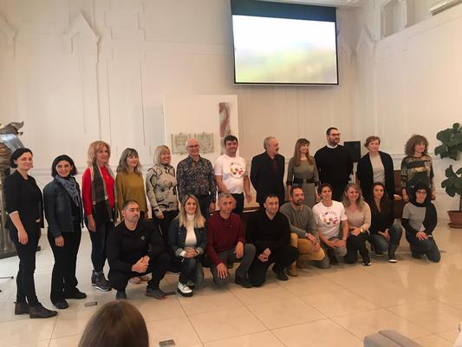
At the first project activity, students were divided into two groups with expert guidance that taught the rules of the game in basketball and tennis.
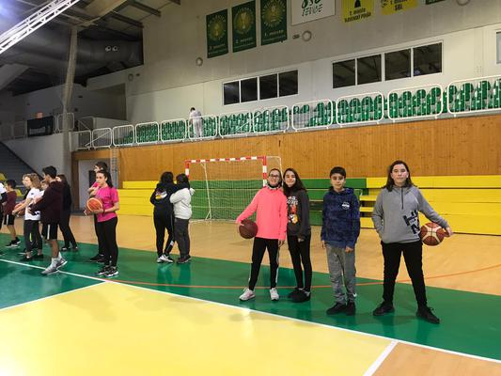 After lunch we spent time visiting the beautiful Levica covered in white snow.

DAY 2
On our second day in Levice we were welcomed in school by students and teachers who were so lovely. 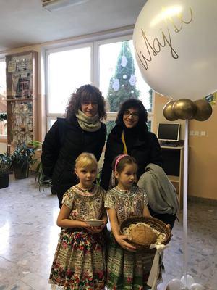
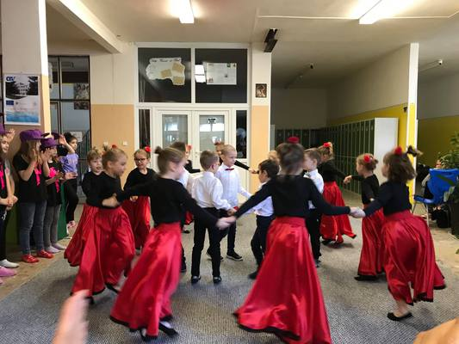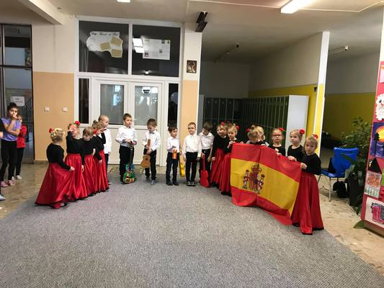
Slovakian students showed us their dances, which was a great memory for us. After a short artistic programme teachers and students from all countries introduced their schools and countries to others.
Then we were invited to a school canteen for a tasty lunch. Students were divided into two groups for project activities- First Aid course and hiking.
Teachers had a chat and visited some classes. We were guided by Milos around the school building.
Later we had teachers’ meeting where we discussed future activities for a project.

DAY 3
On Wednesday we travelled to Banska Stiavnica. We climbed to the Calvary Mountain and we took some really nice pictures from the panoramic views and the red church on top.
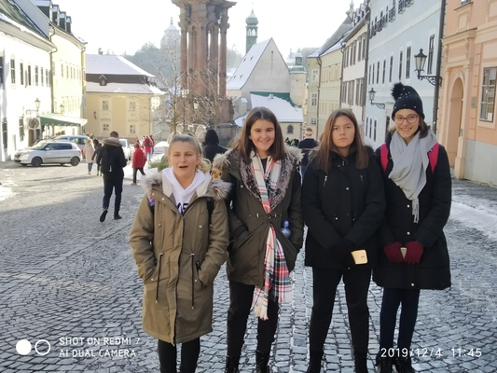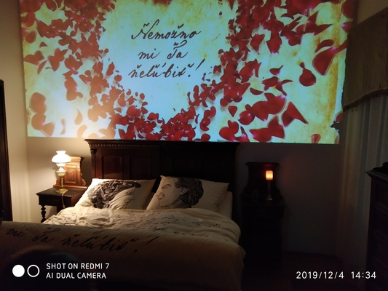
After, we went to the city centre and wandered along the picturesque streets to end in the Katolicka skola where we had lunch teachers and students from the different countries. Then, we visited the Love Bank, where we got to know the unfulfilled romantic story between Marina and Andrej Sládkovič, which was the reason for the creation of the world's longest love poem.
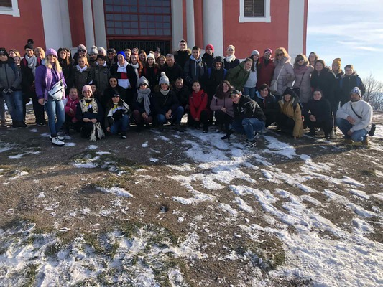
DAY 4

On Thursday the students went to school because there was a basketball and a tennis tournament.The teachers went to school at ten for teachers meeting to plan the next mobilities.After lunch we came back to our hotel to be ready for ceremony.All the participants took their certificates from Matej Tóth hands.We watched traditional folk dances and listened to traditional folk songs.We had dinner together with all participants and the teachers who work in Katolicka spojena skola.We showed our abilities to St.Nicholas to have some chocolate.All teachers danced together ,and finished the day thinking we don’t need to speak the same language to come together and have fun.
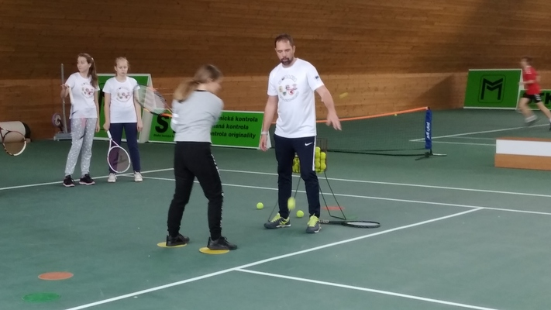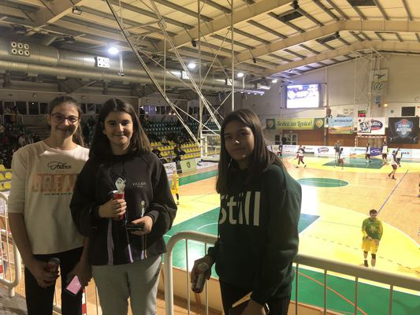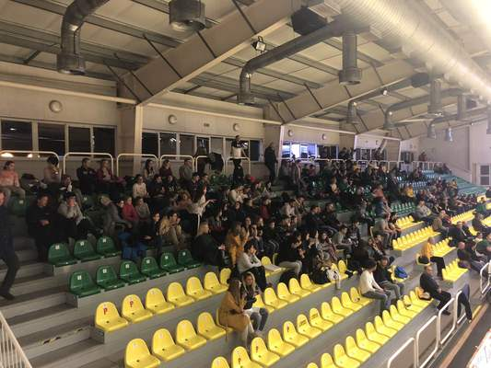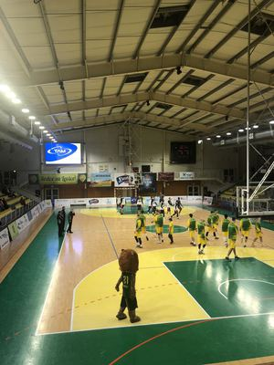
DAY 5

On Thursday the students went to school because there was a basketball and a tennis tournament.The teachers went to school at ten for teachers meeting to plan the next mobilities.After lunch we came back to our hotel to be ready for ceremony.All the participants took their certificates from Matej Tóth hands.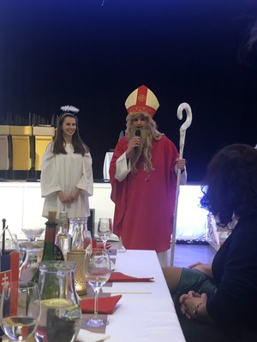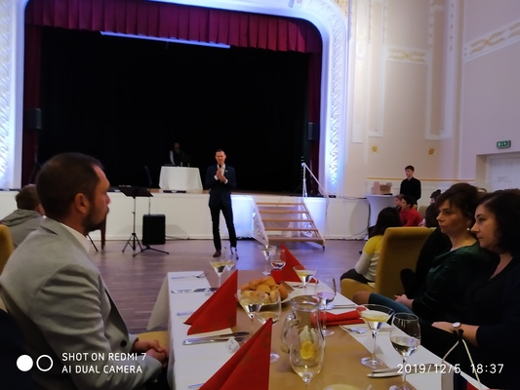We watched traditional folk dances and listened to traditional folk songs.We had dinner together with all participants and the teachers who work in Katolicka spojena skola.We showed our abilities to St.Nicholas to have some chocolate.All teachers danced together ,and finished the day thinking we don’t need to speak the same language to come together and have fun.

