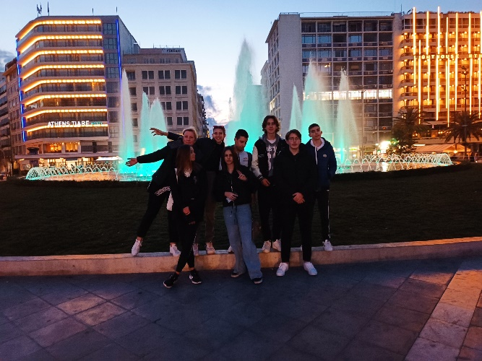
STREAMing through Europe

Monday 6 March 2023, the first day in beautiful Greece

Today we met each other and were introduced to our Greek Colleague school, The Evangelical School of Smyrna in Athens. After a warm welcome at the playground of the school, we got a short tour of the school.

Afterwards there was a very nice official opening of the project. The
headmaster spoke some words of welcome and told us about the background of the Greek Myths. We
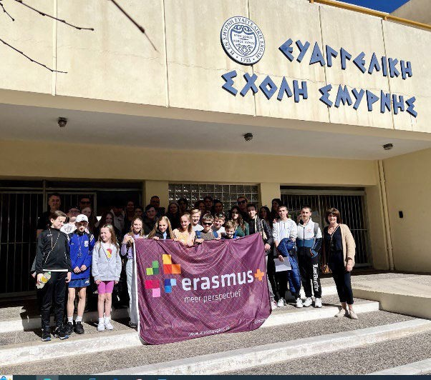
learned that they were intended to make incomprehensible phenomena understandable.

Then, the Greek pupils treated us on very nice music. This music was live played and sung by them. Of course there was some explanation about the songs and the Myths behind them. The Irish group had prepared a dance and put on a nice performance together.
Then there was time to play some "icebreaking" games. The games made sure the pupils got to know each other quickly by collaborating, having fun and laughter together. Skills as concentration and focus on each other were necessary to complete the games successfully.

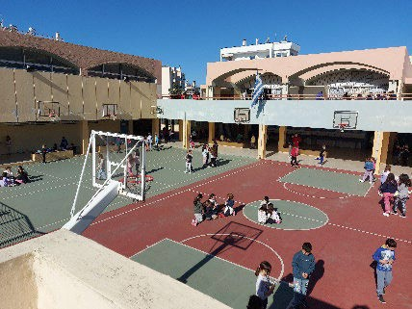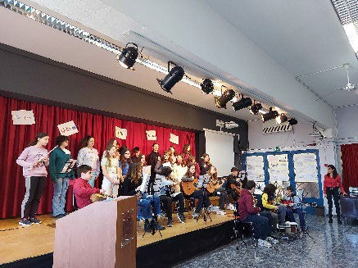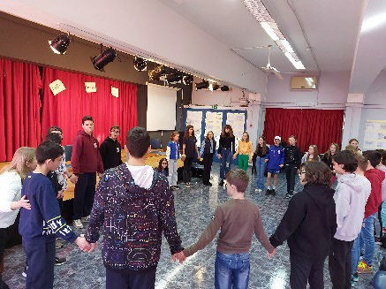

After a nice Greek snack we started the afternoon in two groups with lessons on the Greek Myths linked to ancient engineering and music. The pupils learned how to create an aluminium jewellery for a necklace made of rope. During the music lesson they
learned a dance and they even learned to read and sing the lyrics of the song in Greek.
They all enjoyed this program.

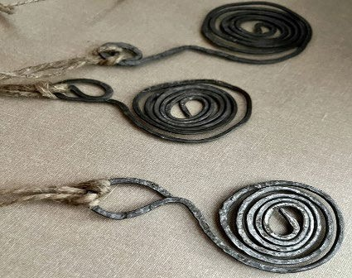
When the lessons were finished, went with the whole group for a walk to a very nice restaurant where we had a delicious Greek lunch. We were spoiled with typical Greek dishes like Gyros, Souvlaki and Greek salad.

While the children talked to each other and enjoyed their lunch, the teachers discussed the project, their experiences in the project and how they experienced live in their own countries. It was a successful afternoon in which a lot was shared with each other, by the pupils as well as by the teachers.

After lunch Christina, the Greek teacher who organised this exchange in her country, took us to the beach. With the whole group we went by tram. There we all had some spare time and could enjoy the sun, the sea and the beautiful view.

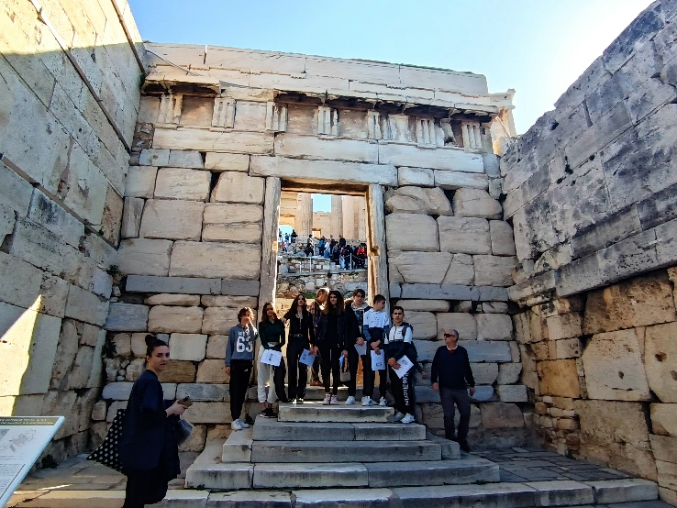
It was such a nice and pleasant closing of the first day of our project in Athens.

A day full of new people to meet, Greek Myths, impressions, experiences and most of all, a day we all enjoyed a lot and we’ll never forget!

Wednesday 8th of March, 2023 - The Acropolis of Athens.
Today after breakfast we all began our lovely walk in the morning sun towards the Acropolis. The fog was lifting from the surrounding mountains and the shop keepers were just beginning to open their shops for the days fair.

We meandered gracefully through the small streets watching a most ancient city awake.
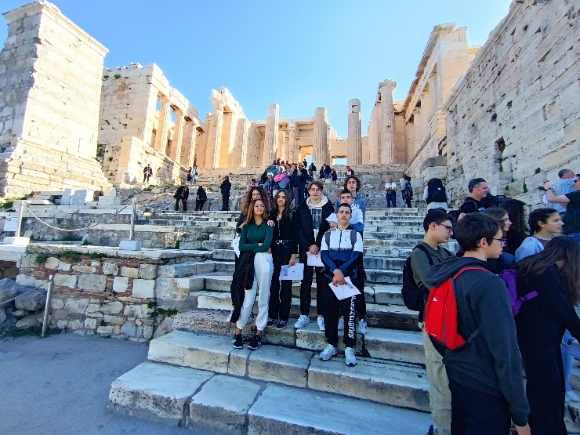
We made our way to the foot of the Acropolis and meet all the Erasmus+ kids and teachers.
It was lovely to see people sitting outside enjoying their morning coffee.
Once everyone was accounted for our Greek colleagues took charge of the sightseeing for the day.

During ancient times the Acropolis of Athens was known also more properly as Cecropia, after the legendary serpent-man, Cecrops, the supposed first Athenian king.
There is evidence that the hill was inhabited as early as the fourth millennium BC but it was in the fifth century BC where the most important of the structures on the hilltop were constructed - including the Parthenon, the Propylaea, the Erechtheion and the Temple of Athena Nike.
Once our tickets were purchased, we entered the complex and made the short climb to the entrance. The children from the Greek school gave wonderful historical accounts of the structures. The children were all given brief explanations of the complex architectural structures from ionic to doric columns. We heard the beautiful tales of the Greek myths which once stood facing the lucky tourists, recounting the wonders of the ancient Greek
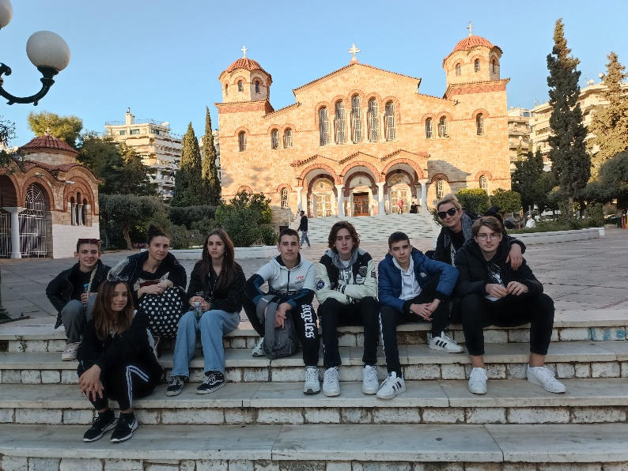
Gods. Unfortunately removed by the British and now houses in the British Museum, London. Hopefully they will one day return home.

The children were all
given a lovely booklet with questions which they would answer at the end of their tour.
Pictures were taken and young inquisitive minds asked questions about times gone by. The wonderful views of the sprawling city amazed all, never mind the views which lay before them.
The food was once again delicious and affordable. The food of Southern Europe, particularly the fruit and vegetables, is tastier than what we experience in Northern climes, due to the sunshine and longer Summers. After a leisurely walk around the Monastiraki district all the students went to and from the souvenirs shops buying trinkets for loved one at home.
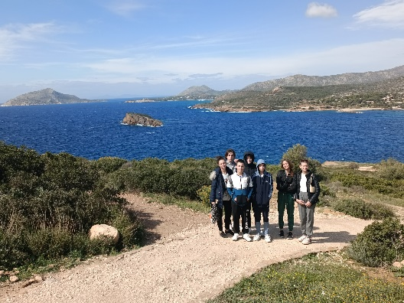
The unfortunate events of last week’s train crash and government inadequacies caused the people of the city to march in protest of the ongoing situation. This brought us all back to where all societies adopted democracy from – Athens.

We also came across the huge protests that have taken place in the capital city in response to the recent train accident that left over 50 dead, including over 40 students. Most of the marchers that we saw adjacent to our hotel were young people and students. We have learned a lot about the challenges that face Greek society and the frustration that young people face. Much of the education that teachers and students receive on these trips is in a non-formal setting and the Greek people have been very willing to talk to us.
We also learned about the challenges of the continuing Anglicisation of European society. English is our mode of communication and has been very useful but the Greek students informed us that an increasing number of students are using ‘Greek-lish’, a mish mash of both languages and sometimes communicate solely in English. The teachers told us of their priority of preserving all facets of their native culture.
Again, we must applaud the Greek people for being so open and welcoming to all us students and educators who they made feel at home.

The story of a day, March 9th

On March 9th, the Croatian team headed to the Monastiraki metro station after breakfast. Upon arriving at Syntagma station, we walked to take the tram that brought us to Evangelikis
Scholi where we met with the other Erasmus+ partners. While the Irish and Dutch students learned about mythology in ancient Greece, the Portuguese and Croatians played musical instruments and sang Greek songs, resulting in a fun and social experience for all involved.
Afterwards, we visited IME, "The Olympian Gods," where we had the opportunity to explore ancient times and mythology. Greek mythology is an essential part of Greek cultural heritage, and its study can help individuals understand the
symbolism of myths and the ancient Greeks' source of knowledge and wisdom. Visiting IME was an enriching experience for both teachers and students as it linked humour with education in an artistic manner.

After enjoying a delicious typical Greek cuisine for lunch, a mix of grilled meat with salad, French fries, tzatziki, and pita, we visited the magnificent National Academy, displaying outstanding old paintings
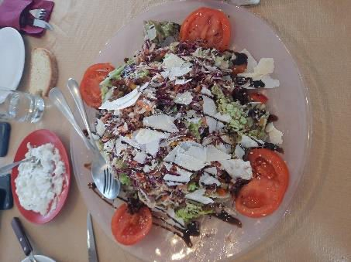
on the walls, the first University in Athens, and the old library, all of which had stunning and breathtaking architecture.
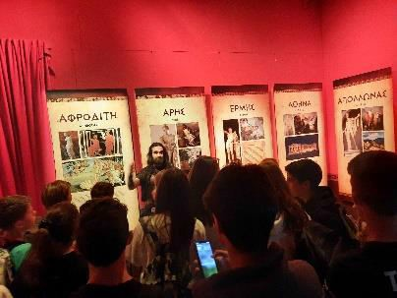
The Academy of Athens (Greek: Ακαδημία Αθηνών, Akadimía Athinón), Greece's national academy and highest research establishment was established in 1926, with its founding principle traced back to the historical Academy of Plato and operates under the Ministry of Education's supervision. The Academy's main building is one of the significant landmarks of Athens.
On our way back to the hotel, we witnessed the meticulous steps and dances that the guards performed during the changing of the guards in front of the Parliament.
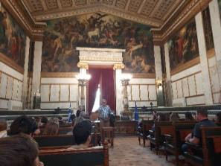
Despite being tired, we were delighted as we learned a lot about Greek cultural heritage, the sculptural architecture of their ancient buildings, and the twelve
Olympians, which is the most popular narrative in Greek history. If you think you know about mythology through Homer’s Iliad and Odyssey, you will be amazed by how much there is still to learn about the twelve Olympians and Greece, widely recognized as
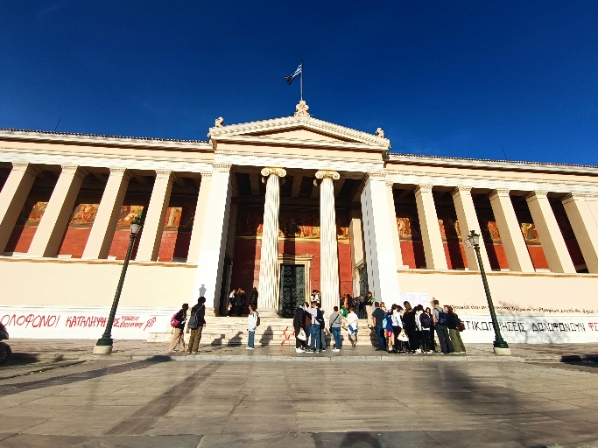
the birthplace of democracy.

The day proved to be a rewarding experience for everyone, reminding us of Leonardo da Vinci's famous quote: "Learning never exhausts the mind.
Friday, April 10th
On the last day of the mobility to Greece, it was time to see other places related to Greek mythology. We gathered early at the school and we headed to Mycenae. Our guide was expecting us to show us around the archaeological site and tell us stories from ancient times.

Our next stop was Nafplion, the first capital of the Modern Greek state, after the War of Independence that started a bit more than 200 years ago, in 1821. We wandered in the narrow streets of the old city, heard a few more stories from our experienced guide and got some free time to see the city in all its glory under the sunny sky.

After lunch we had some free time for photos and an afternoon cup of coffee or an ice cream in the old neighbourhood or by the sea. Late in the afternoon, we set off again for Athens, tired but excited and happy to have spent the whole day with our new friends. The few tears that were shed at the end of the day will hopefully mean the beginning of long-lasting friendships among the students of our countries! See you all in our next mob

