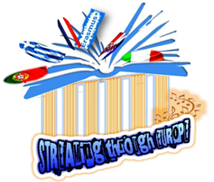

PROGRAM SCHEDULE from 8. — 13. NOVEMBER, Trogir, Croatia
www.os-kralja-zvonimira-st.skole.hr/skola/erasmus_
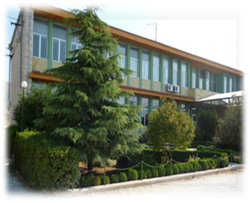

On behalf of our school King Zvonimir Elementary School, Seget Donji, Croatia, within the ongoing Erasmus + KA229-Partnership Partnership in School Exchange, 2020-1-NL01-KA229-064553_3, we officially send to your school Model junior high school Evangeliki Scholi Smyrnis planned activities and program schedule

DAY 1. 8.11.2021.
9h | ENTRANCE
- WELLCOME SONG
- SPEACH
- VIDEO PRESENTATION OF COUNTRY, CITY AND SCHOOL
- School programe in Croatia-introducing to each others
10:00h | - Coffee tea cake
11:00h | - Sports, hanging together
14:00 h | - LUNCH
15:00h | - MEETING IN TROGIR  - At 8 locations PUPILS get a short text and tasks the correct answer leads to the next location - + city map  - WORKSHOP Trogir ESCAPE BOOK -escape the city  - Escape the book genially ONLINE

DAY 2. 10.11.2021.
7:00h | Departure by tourist bus in front of the school towards the city of Dubrovnik  city ​​tour with a local guide (English): Stradun, Minčeta Tower, Revelin Fortress, mOnorph's Fountain, Rector's Palace,
Sightseeing of Dubrovnik walls and city panorama or cable car ride (optional).
CREATIVE LETTERS FOR NEW CREATED FAIRYTALE FOR – WORKSHOP OF DRAWING LETTERS!
14:00h | LUNCH
After lunch, boat ride to the nearby island of Lokrum. Island tour and contents.Mythological place for narrative cards for motivation to write a good story
Return by boat to Dubrovnik.
Rest and departure by bus to Seget.
Driving on the highway with short stops.
Arrival in the evening.

DAY 3. 9.11.2021.
9:00h | CITY SPLIT | 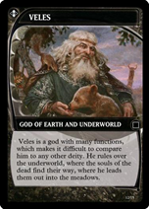  City library Marko Marulić Split - Central Library Optional  WORKSHOP OF CREATIVE WRITING  Making a fairy tale with characters from Slavic mythology-workshops  NARATIVE CARDS WITH LOCATIONS, MOTIFS, CHARACTERS AND THEME  Visiting Split with local guide on English
14:00h | LUNCH
16:00h | Adventure Zagora-Izletište Podastrana | Workshop illustrate a fairytale

DAY 4th and 5th 11.11.2021.-12.11.2021.
9:00h | GOING FOR OGULIN
11:00h | "Ivana's fairytale house", a museum dedicated nfairy tales whose founding was inspired by the world-famous children's writer, Ogulinka Ivana Brlić  Mažuranić. We take a workshop of your choice. Rest and return by highway.  This is the place for educational and fun workshops which promote the knowledge of fairy tales and inspire creativity.
14:00h | Plitvce lakes, most visited national park in Croatia under the protection of UNESCO since 1950.  years. Sightseeing of a large waterfall, a walk along the trail, a boat ride on Lake Kozjak and a train-bus ride.  Holidays for games and entertainment near Lake Kozjak. Rest and continue driving towards the town of Slunj. Stopping  for lunch. After lunch, departure for Rastoke. Upon arrival, we tour Rastoke, the waterfalls that have formed  by the play of nature at the confluence of the river Slunjčica and the river Korana. Nature played with the blue-green waters of the river-mythological place…….Discussing miths and legends of Croatia  Lake Sabljaci where we have lunch.  LUNCH AT SLUNJ OR OGULIN
16:00h  5th day  16:00:00h | OVERNIGHT IN ZAGREB  We visit Ban Jelačić Square, the Cathedral, Tkalčićeva Street, the Stone Gate, St. Mark's Square, Banske  court, Lotršćak tower, cable car ride and descent to Ilica. Free time in the square for photography.  Departure for the hotel. Accommodation in a hotel ***.  Din  Breakfast. After breakfast, pack your bags and go on a tour of the Technical Museum (optional) or the Museum  Illusion (optional  Time for say goodbuy!!!

We are informing you that the scedrual can be changed in order to improve activities and for better achiving the goals of this project.
Headmaster
Mr. Dominik Matković
_______________________

